SET 1

I. | LAB TEST
1. | Write a Python program to store book records in a binary file named BOOK.DAT.  Each book record should contain the following details: [BookID, BookName, Author, Price] After storing the data, define a function countRecords() that performs the following operations.(Use the pickle module to perform binary file operations)  - Displays the details of all books whose price is greater than Rs. 5000 and counts the number of such books.  - Displays the total number of all books stored in the file. | 8
import pickle
def addBooks():
file = open("BOOK.DAT", "wb")
n = int(input("Enter number of books: "))
print("Enter the book details: ")
for i in range(n):
print("\nEnter book details")
bid = int(input("Book ID: "))
bname = input("Book Name: ")
author = input("Author: ")
price = float(input("Price: "))
book = [bid, bname, author, price]
pickle.dump(book, file)
file.close()
def countRecords():
file = open("BOOK.DAT", "rb")
count = 0
total = 0
print("\nBooks with price more than Rs. 5000:")
try:
while True:
book = pickle.load(file)
total += 1
if book[3] > 5000:
print(book)
count += 1
except EOFError:
pass
file.close()
print("\nNumber of books costing more than Rs. 5000:", count)
print("Total number of books:", total)
addBooks()
countRecords()

2. | Consider the following tables BOOK and MEMBER and answer the questions that follow:  TABLE : BOOK  TABLE: MEMBER  Write SQL commands for the following:  - To display the names of all books whose price is more than 1000.  - To display BookName and Author of books in ascending order of Price.  - To display the highest price of a book from the BOOK table.  - To display the Member name and the Book name issued to them | 4
  BookID | BookName | Author | Price
  B101 | Python Basics | A. Sharma | 650
  B102 | SQL Made Easy | R. Verma | 1200
  B103 | Data Science | S. Mehta | 1800
  B104 | Web Design | K. Rao | 900
  MemID | MName | BookID
  201 | Rohit Kumar | B101
  202 | Neha Singh | B103
  203 | Aman Gupta | B102
Queries

mysql> create database;
mysql> use book;
mysql> create table book(BookId varchar(5) primary key,BookName varchar(20),Author varchar(20),price integer);

mysql> insert into book values('B101','Python Basics','A.Sharma',650),
('B102','SQL Made Easy','R.Verma',1200),
('B103','Data Science','S.Mehta',1800),('B104','Web Design','K.Rao',900);

mysql> create table member(MemberID integer primary key,MName varchar(20),BookId varchar(5));

mysql> insert into member values(201,'Rohit Kumar','B101'),
(202,'Neha Singh','B103'),(203,'Aman Gupta','B102');

- SELECT BookName FROM BOOK WHERE Price > 1000;

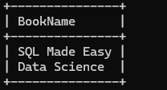

- SELECT BookName, Author FROM BOOK ORDER BY Price ASC;

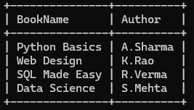

- SELECT MAX(Price) FROM BOOK;
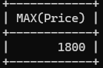

- SELECT MEMBER.MName, BOOK.BookName FROM MEMBER, BOOK WHERE MEMBER.BookID = BOOK.BookID;

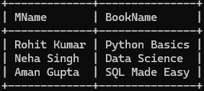

SET 2
I. | LAB TEST
1. | Write a Python program to store employee records in a CSV file named EMPLOYEE.CSV. Each employee record should contain the following details:[EmpID, EmpName, Desig, Salary] After storing the data, define appropriate functions to perform the following operations:  - Display the details of employees whose salary lies in the range of Rs. 5000 to Rs. 15000 and count the number of such employees.  - Search and display the details of an employee using EmpID entered by the user. |  |  |  |  |  |  |  |  | 8
 | 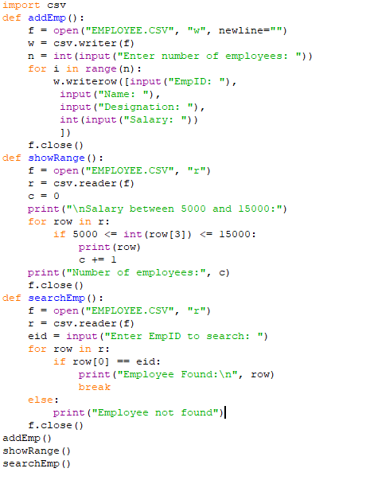
2. | Observe the following tables Employee Details and Employee Salary and write queries given below::  TABLE: EMPLOYEE DETAILS |  |  |  |  |  |  |  |  | 4
2. | EmpID |  | FullName |  |  | ManagerID |  | Date of Joining | City | 4
2. | 121 |  | John Snow |  |  | 321 |  | 31-01-2014 | Toronto | 4
2. | 321 |  | Walter White |  |  | 986 |  | 30-01-2015 | California | 4
2. | 421 |  | Kuldeep Rana |  |  | 876 |  | 27-11-2016 | New Delhi | 4
2. | TABLE: EMPLOYEE SALARY |  |  |  |  |  |  |  |  | 4
2. | EmpID | Project |  | Salary | Variable |  |  |  |  | 4
2. | 121 | P1 |  | 8000 | 500 |  |  |  |  | 4
2. | 321 | P2` |  | 10000 | 1000 |  |  |  |  | 4
2. | 421 | P1 |  | 12000 | 0 |  |  |  |  | 4
2. | Write SQL queries for the following:  - Write an SQL query to fetch the EmpID and FullName of all the employees working under Manager with id – ‘986’.  - Write an SQL query to fetch the different projects available from the Employee_Salary table.  - Write an SQL query to find the maximum, minimum and average salary of the employees.  - Write an SQL query to find the employee id whose salary lies in the range of 9000 & 15000.  Queries  mysql> create table Employee_Details(EmpId varchar(5) primary key,FullName varchar(20),ManagerID varchar(20), Date_of_Joining date,City Varchar(2));  mysql> insert into Employee_Details values(121,'John Snow','321','2014-01-31','Toronto'), (321,'Walter White','986','2015-01-30','California'),(421,'Kuldeep Rana','876','2016-11-27','New Delhi');  mysql> create table Employee_Salary (EmpId varchar(5) primary key,Project varchar(20),Salary integer,Variable integer);  mysql> insert into Employee_Salary values(121,'P1',8000,500),(321,'P2',10000,1000),  (421,'P',12000,0);  - SELECT EmpID, FullName FROM Employee_Details WHERE ManagerID = 986;  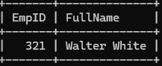  - SELECT DISTINCT Project FROM Employee_Salary;    - SELECT MAX(Salary) AS Maximum_Salary,MIN(Salary) AS Minimum_Salary, AVG(Salary) AS Average_Salary FROM Employee_Salary;  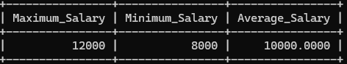  - SELECT EmpID, Salary FROM Employee_Salary WHERE Salary BETWEEN 9000 AND 15000;  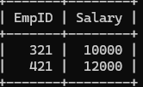 |  |  |  |  |  |  |  |  | 4

